**Ideation Phase**

**Define the Problem Statements**

|  |  |
| --- | --- |
| Date | 26 June 2025 |
| Team ID | LTVIP2025TMID46251 |
| Project Name | **HematoVision: Advanced Blood Cell Classification Using Transfer Learning** |
| Maximum Marks | 2 Marks |

**Problem Statement:**

Pathologists, lab technicians, and healthcare providers face significant challenges in classifying blood cells using traditional manual methods. These processes are slow, prone to errors, and require skilled expertise, which is often unavailable in rural or under-resourced areas. This leads to diagnostic delays, inconsistent results, and overburdened professionals. Medical students also lack engaging, real-time tools for learning cell classification. There is a strong need for an automated, accurate, and accessible solution that enhances diagnostic efficiency, supports remote healthcare, and improves medical training outcomes.

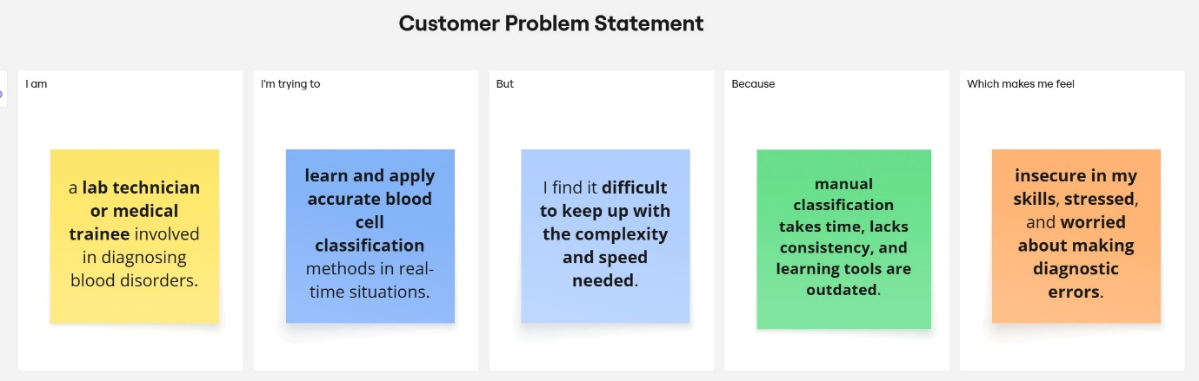

|  |  |  |  |  |
| --- | --- | --- | --- | --- |
| I am | I’m trying to | But | Because | Which makes me feel |
| a **lab technician or medical trainee** involved in diagnosing blood disorders. | **learn and apply accurate blood cell classification** methods in real-time situations. | I find it **difficult to keep up with the complexity and speed needed**. | **manual classification takes time, lacks consistency, and learning tools are outdated**. | **insecure in my skills**, **stressed**, and **worried about making diagnostic errors**. |